Electronics Documentation

1. Electronics Block Diagram
Show signal and power flow
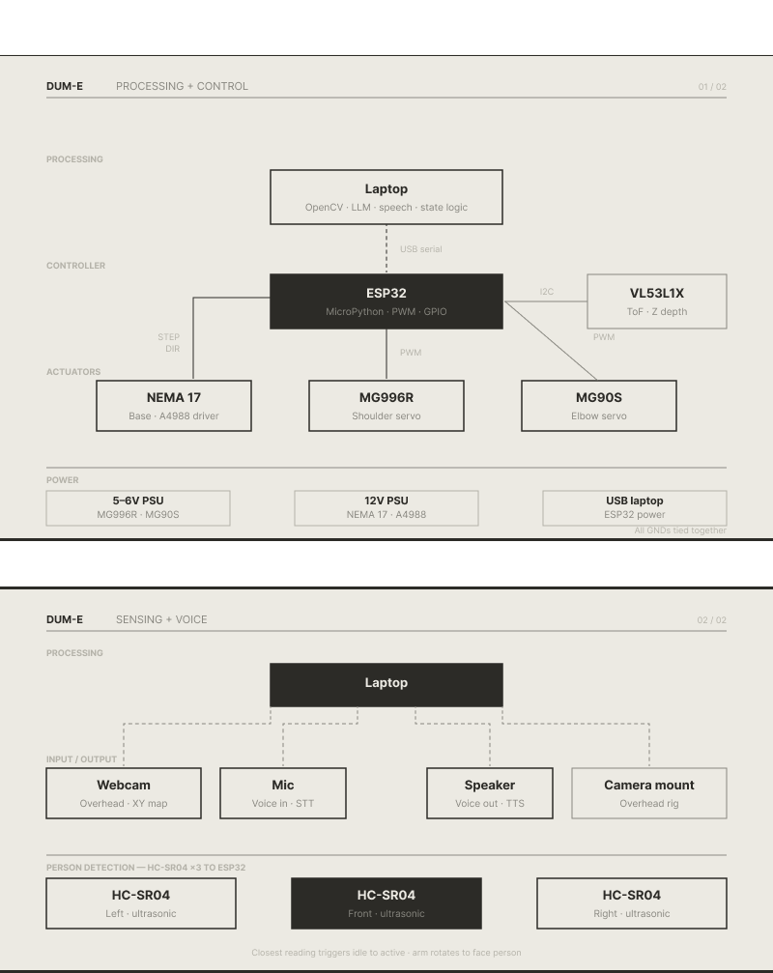
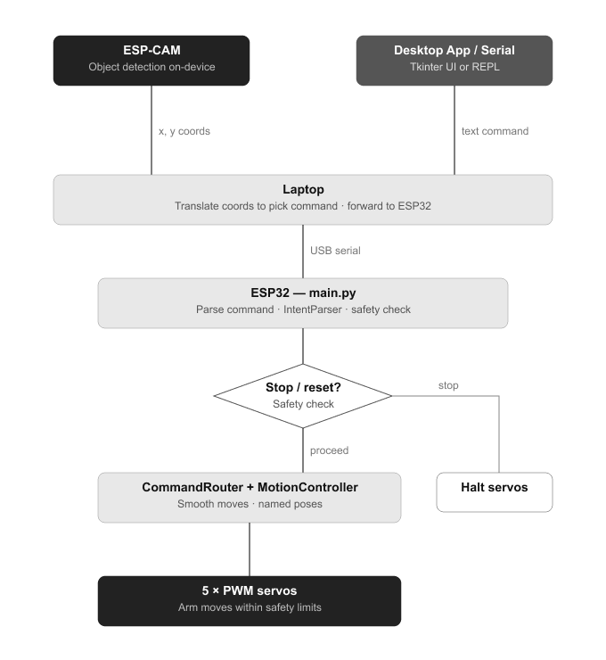

2. Components Table
Component | Quantity | Purpose | Justification
ESP32 development board | 1 | Run MicroPython, PWM for five servos, USB for programming and serial control | One MCU with enough GPIO for five PWM channels and USB; matches firmware and deploy workflow.
servo motors:  mg996R  Mg90s  sg90s | 5 | Move waist, upper arm, forearm, wrist, and gripper | Settable angles per joint for a small arm
Jumper wires / breadboard | As needed | Prototype connections before final harness | Standard for lab wiring and iteration.
5v Power Supply | 1 | To power the components | Required for energy
PCA9685 | 1 | To control the servos without fluctuations | Required for the servos to avoid current fluctuations
Esp 32 cam | 1 | To map the objects on the table | Required to map the surface and object detection
Justification is important

